# **CornerstoneSmallChange Request Document**

Date: September 13, 2000 Document #: WRC010

**Change Request: Monthly Sales & Forecast Sales Combination Form**

Jon _____ brought to my attention the need for a form showing Monthly Sales detail (one record line per year, month, customer and product) coupled with a Forecast Sales grid showing records based upon the same filter criteria. A form of this nature would allow for sales review and direct data entry of forecast information based on the previewed sales history.

Currently the Forecast Sales Data Entry form is designed to show Monthly Sales once a forecast record has been entered and saved.

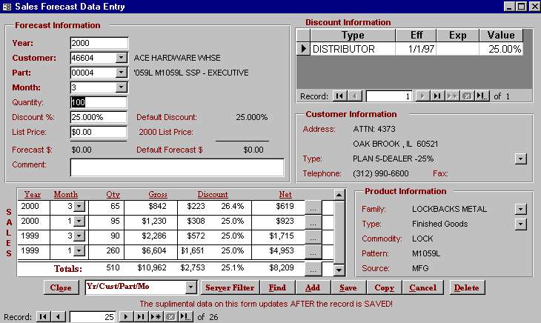

Lookup information

* Monthly Sales
* Customer Address
* Product Family

Only “populates” (shows up!) after a new Forecast Sales record has been entered and saved to the disk.

The proposed form would show Monthly Sales and the Forecast Sales simultaneous based on the filter conditions entered at the top of the form. For those sales records on the left missing a related forecast record on the right, forecasts could be directly entered into this form. A proposed sketch is shown below.

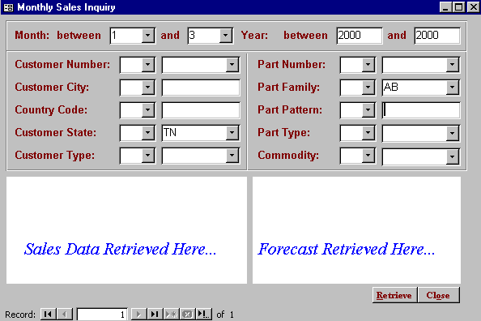

Sales data would show here based on the filter criteria above *but not contingent upon related forecast records on the right.*

Filter criteria allowing for multiple filter selections.

Forecast data would show here based on the filter criteria above *but not contingent upon related sales records on the left.* New forecasts could be entered here.

**Cost:**

Cornerstone Technologies Group estimates 4 – 8 hours to complete the programming behind the proposed form shown in screen print #2 above. The billable hourly rate would be $xx.00 / hour for this service not exceed eight hours.

**Approval:** ______________________________

###### Client Name Cornerstone Technologies Group

###### Senior Management Delora J. Burrow

*or*

____________________________

###### Client Name

###### Project Coordinator